CS 305 Module Two Coding Assignment Template
Jodie Snodgrass
31 October 2025
CS 305 Module 2

Run Dependency Check

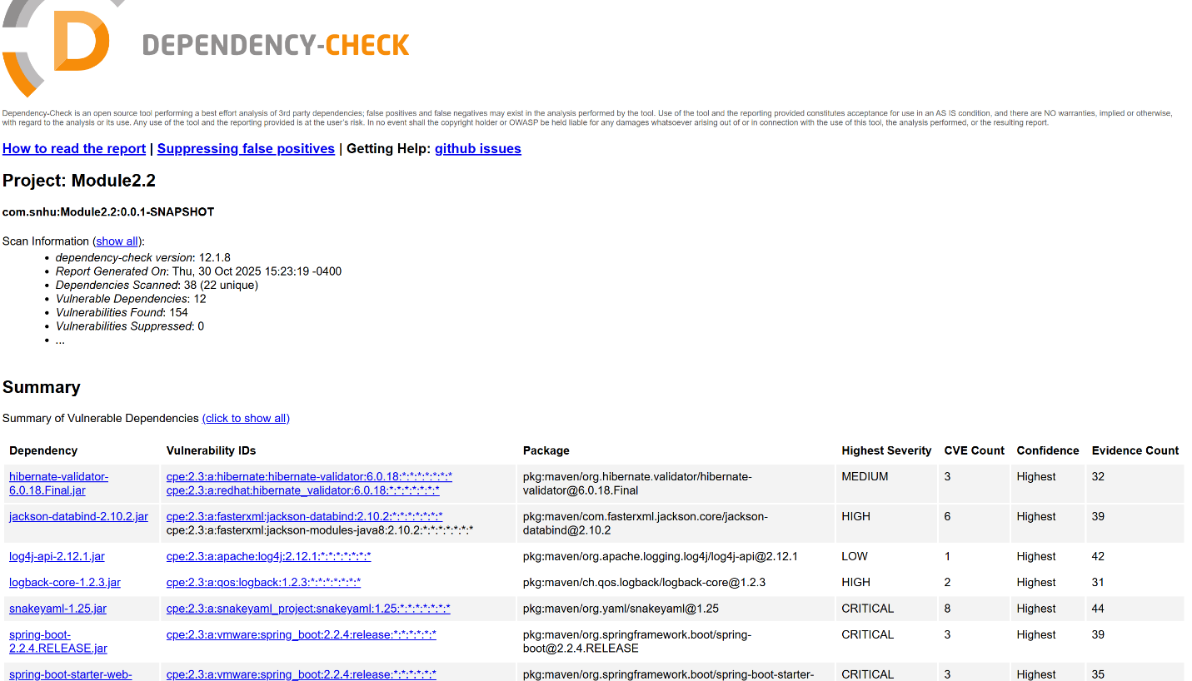
This screen shot shows how the dependency check is the latest version 12.1.8 and all dependencies scanned. The screenshot also shows the date ran, dependencies scanned, vulnerable dependencies, vulnerabilities found, and vulnerabilities suppressed.

Document Results

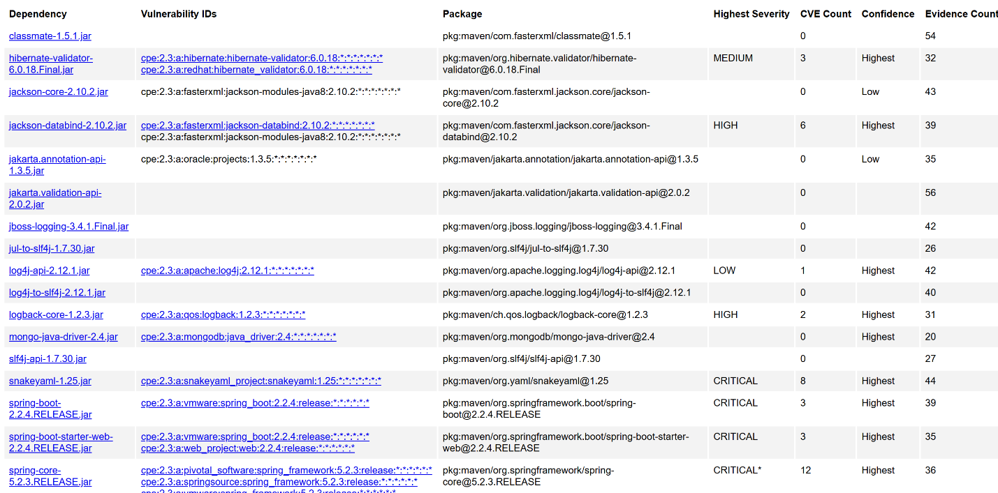
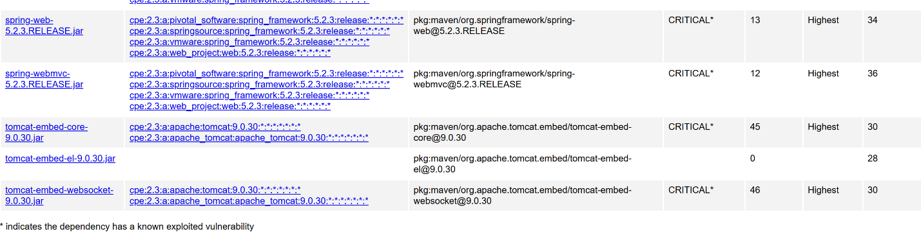
In these screen shots we can see highest severity, CVE count, confidence, and evidence count for each dependency. Dependencies with no CVE count have no highest security or confidence values but they do show evidence counts which included 9 dependencies. There is one low severity with the highest confidence and an evidence count of 42. One dependency shows as medium severity with highest confidence and evidence count of 32. Two dependencies show as high highest severity with both being highest confidence one has a value of 39 evidence count and the other shows as 31 evidence count. 8 dependencies show as being critical with 5 having known exploited vulnerability. All critical dependency show as having the highest confidence the first shows of evidence count of 44 and the following are 39, 35, 36, 34, 36, 30, 30.

Analyze Results

By the dependency check I can see there are many different dependencies that are at risk of having poor security. Critical risk should be addressed first and next high risk and then finally low risk. According to the dependency report with multiple upgrades a lot of these security issues may be resolved. To secure the tomcat-embed-websocket-9.0.30.jar it is recommended to upgrade to version 11.0.2, 10.1.34 or 9.0.98. If Apache Tomcat connections are available to an attacker, they can be exploited. Tomcat-embed-el-9.0.30.jar would need the same update. Spring-webmvc-5.2.3.RELEASE.jar in versions 5.2.0 - 5.2.8, 5.1.0 - 5.1.17, 5.0.0 - 5.0.18, 4.3.0 - 4.3.28 are older versions and must be updated to protect against RFD attacks from CVE-2015-5211 may be bypassed depending on the browser used through the use of a jsessionid path parameter. In the spring-web-5.2.3.RELEASE.jar dependency a Spring MVC or Spring WebFlux application running on JDK 9+ may be vulnerable to remote code execution through data binding. This also needs the same update from older versions being 5.2.0 - 5.2.8, 5.1.0 - 5.1.17, 5.0.0 - 5.0.18, 4.3.0 - 4.3.28. In the snakeyaml-1.25.jar
SnakeYaml's Constructor class does not restrict types which can be instantiated during deserialization which an attacker can use remote code execution to attack. It should be upgraded to version 2.0 and beyond to help prevent an attack. In dependencies slf4j-api-1.7.30.jar, mongo-java-driver-2.4.jar, log4j-to-slf4j-2.12.1.jar, jul-to-slf4j-1.7.30.jar, jboss-logging-3.4.1.Final.jar, jakarta.validation-api-2.0.2.jar, and classmate-1.5.1.jar there are no cve counts and no confidence needing no updates. In logback-core-1.2.3.jar an update is needed to prevent poisoned data from being received. In log4j-api-2.12.1.jar it shows improper validation of certificate with host mismatch in Apache Log4j SMTP appender. That could allow an SMTPS connection to be intercepted by a man-in-the-middle attack that could leak any log messages sent through the appender. In the jackson-databind-2.10.2.jar an issue was found in FasterXML Jackson Databind, where it did not have entity expansion secured properly. This can cause vulnerability to XML external entity attacks. The final jar file with issues is the hibernate-validator-6.0.18.Final.jar. Hibernate Validator before 6.2.0 and 7.0.0 may interpolate user-supplied input in a constraint violation message with Expression Language possibly allowing an attacker to access sensitive information or execute arbitrary Java code. Hibernate Validator as of 6.2.0 and 7.0.0 does not interpolate custom constraint violation messages with Expression Language and strongly recommends not allowing user-supplied input in constraint violation messages so an update is needed.

